# Personal Portfolio – Mitchell Sainty

## Artefact 1 – Flashed up UI

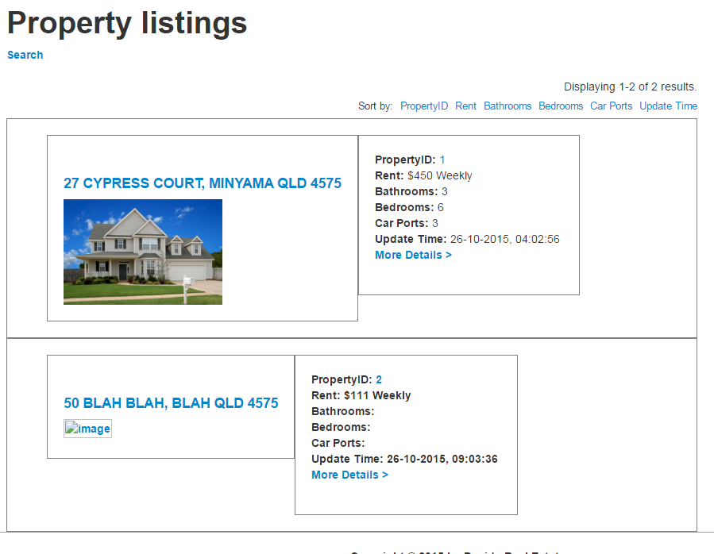

Figure : Our property listing index

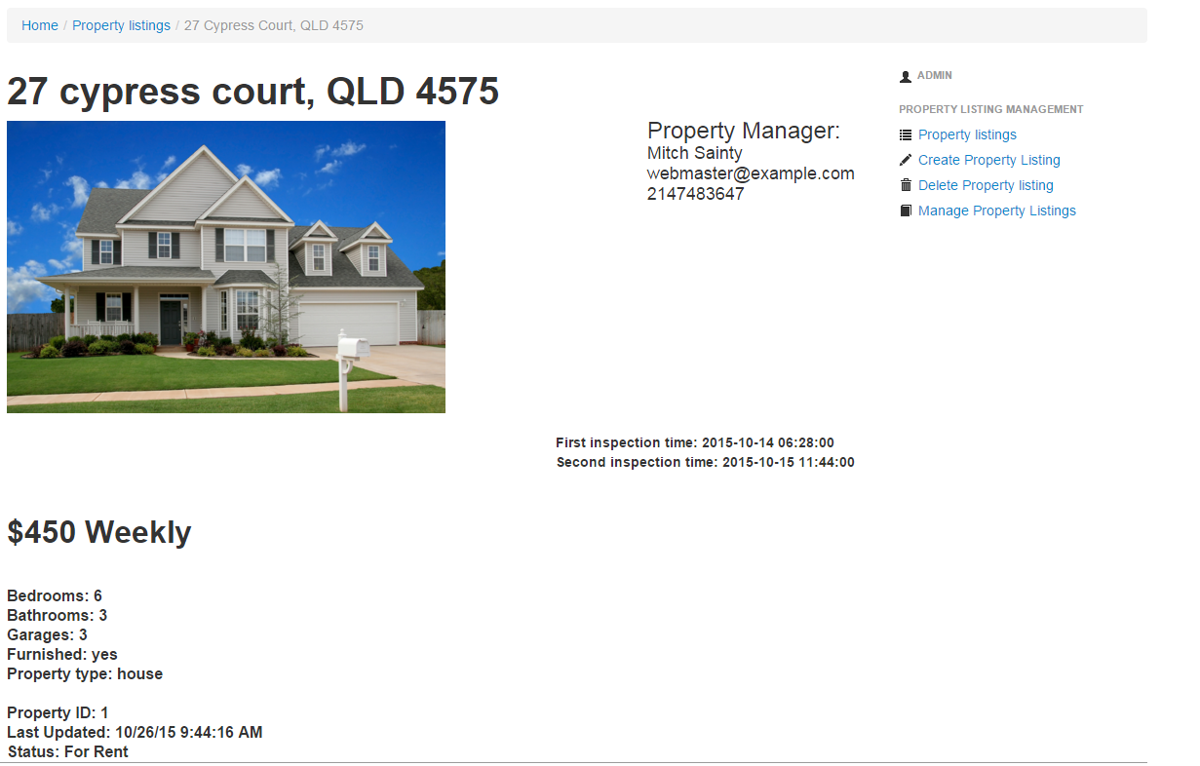

Figure : Our view ui for each property listing

**Description:**

We needed to make sure our website had an appealing UI for both the individual view of a property listing refer to figure 1 and figure 2 for final products.

## Artefact 2 – Implemented Register page

## 

Figure : register account page

**Description:**

Implemented register account page complete with captcha, note password and confirm password field refer to figure 3.

## Artefact 3 – Implemented role based action control

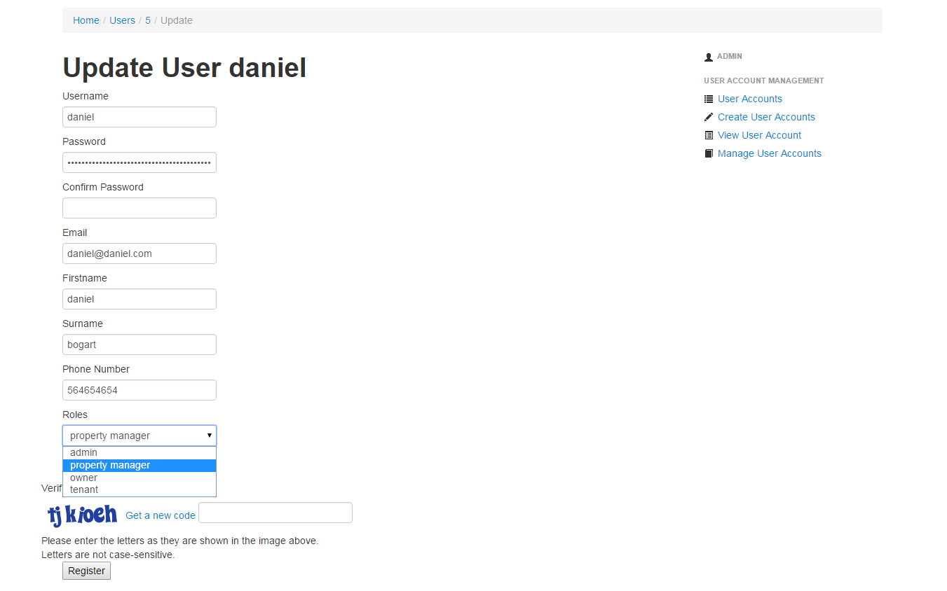

Figure : changing roles of user account daniel

**Description:**

Admin can update use accounts and change roles to admin, property manager, owner or tenant as seen in figure 4. This can then be checked throughout our website with our call to checkAcess(‘roles’) which returns true if roles = instance of log in roles.

## Artefact 4 – Added inspection time1 + Inspection time 2 forms + property manager + tenant

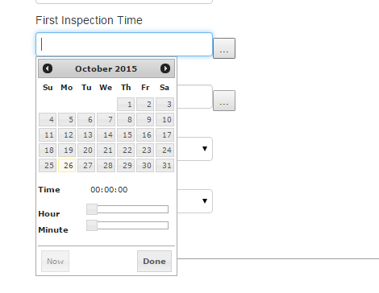

Figure

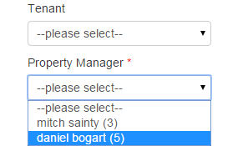

Figure

**Description:**

One of the requirements to our user story was to have it so David could list 2 inspection times on his listings and a property manager as well as a tenant. Referring to figure 5 you can see the time date select form for inspection time 1 and referring to figure 6 you can see a drop down menu populated with account that have role’ property manager’. Furthermore in figure 2 you can see an instance where both inspection times and property manager information has been listed.

.

## Artefact 5 – Completed implementation of user menus, depending on role

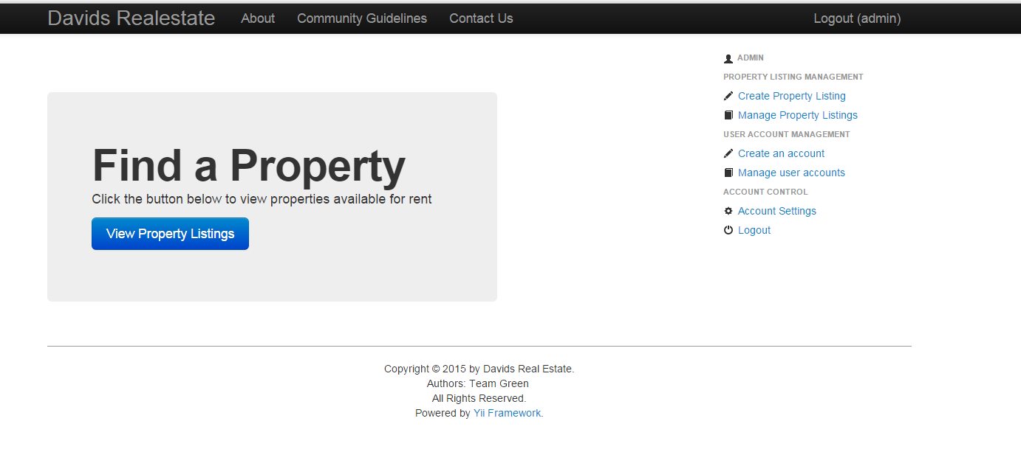

Figure

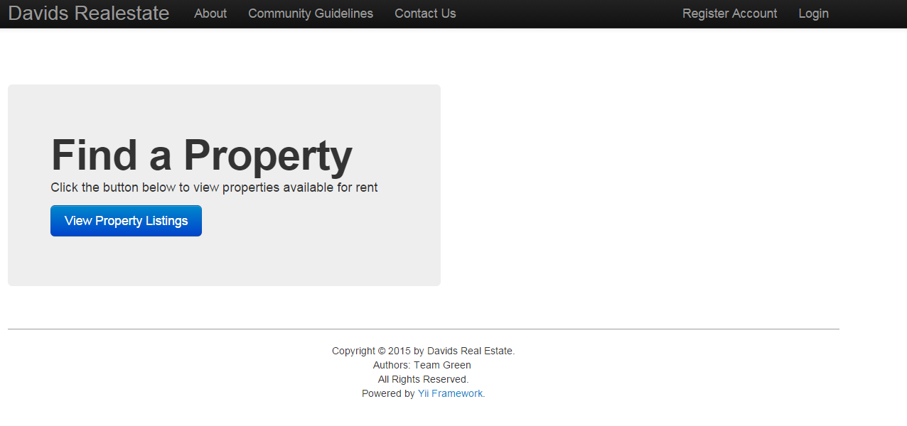

Figure

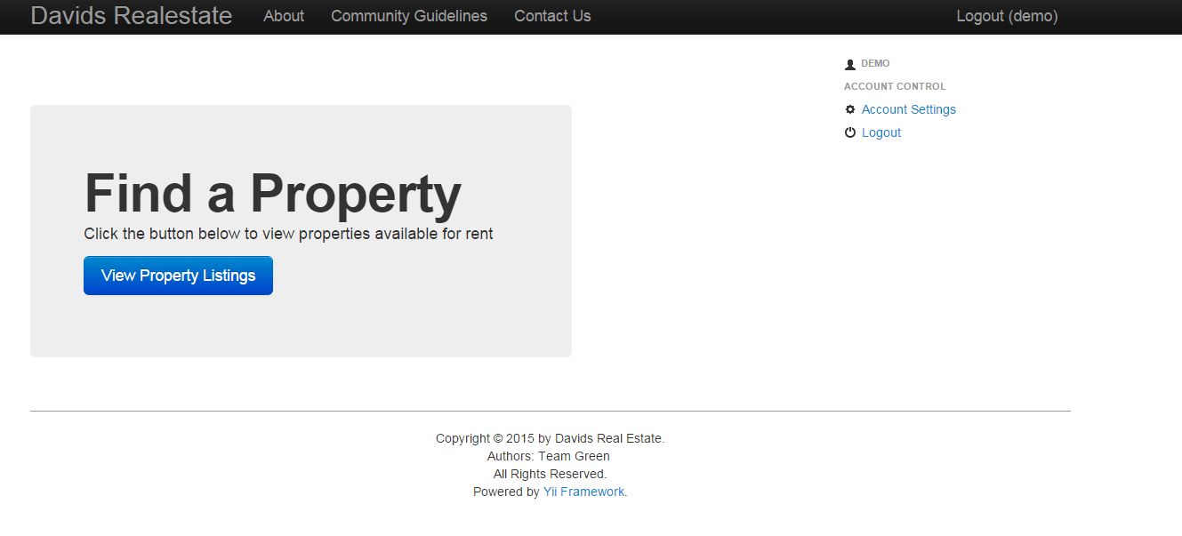

Figure

**Description:**

One our customer requirements was to have different views for different accounts as you can see in figure 7 this is our admin view for our home page. Note the user menu implemented on the left displaying the various admin options. Next note figure 8 this is our home page when there is no log in (user is guest) note there is no user menu displayed and finally referring to figure 9 where the demo account is logged in, this is the view that is displayed for any user that is note roles = admin. Not the user can log out and change account settings.